

WILSON
Version 1 – For Gateway Determination.

April 2018

January 2018

Planning
Proposal

Planning
To amend WLEP 2010 to rezone land at 22 Parkes Road Moss Vale NSW 2577 (Lot 2 DP 1049909) from IN2 Light Industrial to R2 Low Density Residential with a minimum lot size of 700m2.

Prepared in accordance with s.3.33 of Division 3.4 of the Environmental Planning & Assessment Act 1979

Civic Centre, Elizabeth St, Moss Vale, NSW 2577.
PO Box 141, Moss Vale. ABN 49 546 344 354
T. (02) 4868 0888 E. wscmail@wsc.nsw.gov.au
Civic Centre, 68 Elizabeth St, Moss Vale, NSW 2577.
PO Box 141, Moss Vale. ABN 49 546 344 354
T. (02) 4868 0888 E. wscmail@wsc.nsw.gov.au

LOCAL GOVERNMENT AREA : WINGECARRIBEE SHIRE COUNCIL

ATTACHMENTS WHICH FORM PART OF THIS PLANNING PROPOSAL

1 | Planning Proposal Request
2 | Report to Council – 10 May 2017
3 | Resolution of Council – 10 May 2017
4 | Delegation Request Form

ADDRESS OF LAND : Lot 90 DP 751253, 18 Spring Street, Moss Vale
Figure 1 - Location of Moss Vale

OBJECTIVES AND JUSTIFICATION

Objectives

The subject land is located at 22 Parkes Road Moss Vale which is indicated in Figure 1 above.

Council is in receipt of a Planning Proposal seeking to rezone the subject site from IN2 Light Industrial to R2 Low Density Residential with a minimum lot size of 700m², consistent with surrounding R2 land.

The site covers an area of some 5,400m² and comprises the western most portion of an area of IN2 Light Industrial zoned land along Lackey Road and Parkes Road Moss Vale as indicated in Figures 2 and 3 below. The IN2 zone is bounded to the north, west and south west by land zoned R2 Low Density Residential with a minimum lot size of 700m². Land to the immediate south and east (across the railway line) is zoned B5 Business Development.

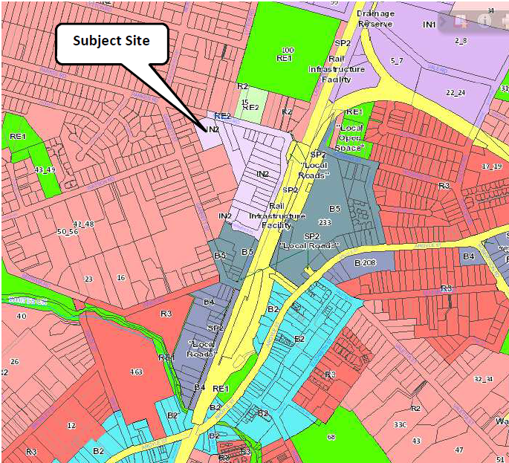
Figure 2 - Location of the Subject Site within a broader zoning context

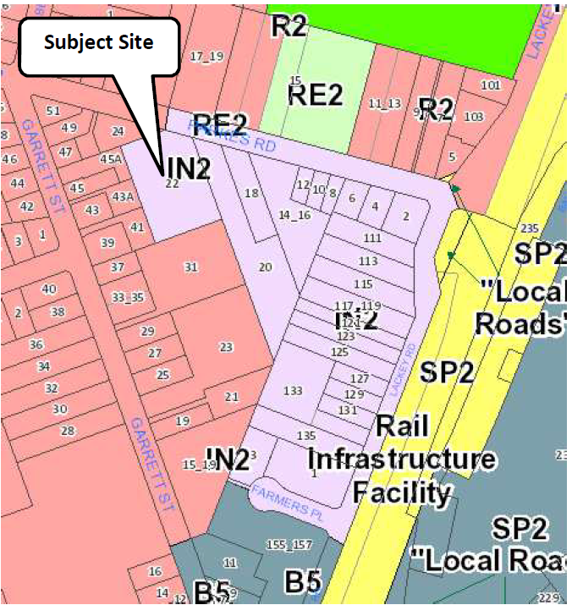
Figure 3 - Detailed Zoning Context for the Subject Site

Strategic Assessment

Council would not normally consider a request to rezone land from an industrial to a residential zone. Ministerial Directions issued under s9.1 of the Environmental Planning & Assessment Act 1979 require Council to demonstrate consistency with those Directions when preparing a Planning Proposal. Direction 1.1 applies to all business and industrial zoned land and requires Council to ensure that the supply of such land is protected. Any inconsistency must be justified. In the case of the subject land, the submission has been prompted by the proponent’s recent relocation of the
previous business from the site.

It is noted that the site effectively extends beyond a straight line between the current R2 and IN2 zones. Under WLEP 1989 the line between the 2(a) Residential zone and the 4(a) Industrial zone ran along the rear boundary of the smaller lots on Garrett Street as indicated in Figure 4 below.

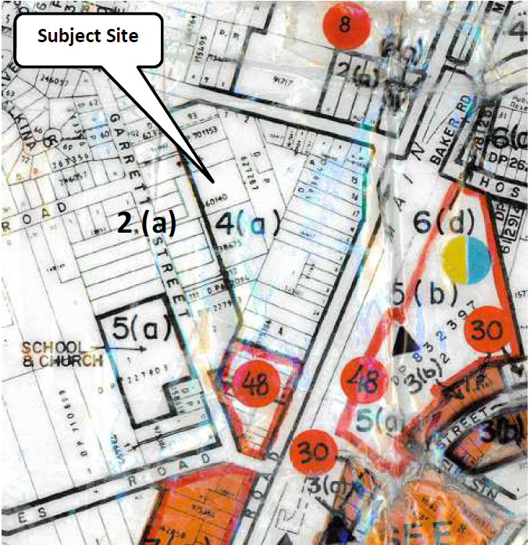
Figure 4 - Zoning map under WLEP 1989 indicating line between 2(a) and 4(a) zones

As indicated in Figure 3 above, under WLEP 2010 the zone boundary was aligned with existing property boundaries, effectively increasing the residential zoned land. The exception was the subject site which retained its industrial zone because of the current land use. With the recent change in that land use, the opportunity does arise to review the zoning.

The land is beyond the range of the Whites Creek Flood study, but any future development of the site would require the preparation of stormwater management studies to support the Development Application.

Council does want to increase opportunities to provide housing choice, in terms of housing type and size, lot size, and location, and the rezoning of the subject land could provide such an opportunity in a location with reasonable access, via Lackey Road and the railway overbridge, to public transport and the Moss Vale commercial centre.

Over time, the subdivision of adjoining larger lots already zoned R2 Low Density Residential on Garrett Street would provide further housing choice opportunities.

In consideration of these matters, at its Ordinary Meeting of Council held on 10 May 2017, Council resolved:

THAT the proposal to rezone Lot 2 DP 1049909, 22 Parkes Road, Moss Vale, from IN2 Light Industrial to R2 Low Density Residential with a minimum lot size of 700m² be supported.

PROPOSED INSTRUMENT AMENDMENTS

No amendment to the WLEP 2010 Instrument is required.

PROPOSED MAP AMENDMENTS

The following map amendments to will be required to achieve the Planning Proposal outcomes:

Maps | Details
Land zoning map | Amend Land zoning map LZN_007D to change the zoning of the subject land from IN2 Light Industrial to R2 Low Density Residential.
Lot size map | Amend Lot size map LSZ_007D to apply a minimum lot size of 700m2 to the subject land.

RELATIONSHIP TO STRATEGIC PLANNING FRAMEWORK

- Is the Planning Proposal consistent with the objectives and actions contained within the applicable regional or sub-regional strategy (including draft strategies)?

The South East and Tablelands Regional Plan was adopted in July 2017. The following table provides a strategic assessment of the Proposal against the relevant Goals and Directions under this Plan.

Regional Plan Direction | Regional Plan Assessment
- Goal 4 Environmentally sustainable housing choices  - Direction 24: Deliver greater housing supply and choice  - Direction 25: Focus housing growth in locations that maximise infrastructure and services  - Direction 27: Deliver more opportunities for affordable housing | The Regional Plan recognises the importance of providing affordable housing choices in convenient locations.  The Planning Proposal supports these Directives by taking advantage of an opportunity to provide additional housing in a location where services exist and which is assessable to public transport and the Moss Vale business centre.

- Is the Planning Proposal consistent with Council’s local strategy or other local strategic plan?

The Wingecarribee Local Planning Strategy 2015-2031 as adopted by Council on 23 March 2016 and conditionally endorsed by the Department of Planning and Environment on 15 May 2017, except for Chapter Four (Meeting Our Housing Needs) on the basis that it relied too much on infill development.

The Planning Proposal provides an example of where appropriate infill development can occur.
Council remains committed to seeking opportunities to provide housing choice, in terms of housing type and size, lot size, and location, and the rezoning of the subject land could provide such an opportunity in a location with reasonable access, via Lackey Road and the railway overbridge, to public transport and the Moss Vale commercial centre.

It is therefore considered that this Planning Proposal is CONSISTENT with the Regional Plan.

CONSISTENCY WITH STATE ENVIRONMENTAL PLANNING POLICIES (SEPPs)

All Proposals are included in the endorsed part of the Wingecarribee Local Planning Strategy 2015-2031. Individual Planning Proposals subsequently submitted to Council included an assessment of the consistency of the Proposal with relevant SEPPs. Those justifications are summarised below.

SEPP | Relevance to Planning Proposal
No.1 Development Standards | NOT RELEVANT – replaced by Clause 4.6 of WLEP2010 as the mechanism for any variation to development standards.
No.14 Coastal Wetlands | NOT RELEVANT – There are no Coastal Wetlands within the Shire.
No.19 Bushland in Urban Areas | NOT RELEVANT – does not apply to Wingecarribee Shire.
No.21 Caravan Parks | RELEVANT – applies to land within Wingecarribee Shire.  CONSISTENT - The Planning Proposal will not result in development for the purposes of a caravan park.
No.26 Littoral Rainforests | NOT RELEVANT – does not apply to Wingecarribee Shire.
No.30 Intensive Agriculture | RELEVANT – applies to land within Wingecarribee Shire.  CONSISTENT - The Planning Proposal will not result in development for the purposes of intensive agriculture.
No.33 Hazardous and Offensive Development | RELEVANT – applies to land within Wingecarribee Shire.  CONSISTENT - The Planning Proposal will not result in hazardous or offensive development.
No.36 Manufactured Home Estates | RELEVANT – applies to land within Wingecarribee Shire.  CONSISTENT - The Planning Proposal will not result in development for the purposes of a manufactured home estate.
No.44 Koala Habitat Protection | RELEVANT – applies to land within Wingecarribee Shire.  CONSISTENT - The Planning Proposal will not result in development which will impact in any way on koala habitat.
No. 47 Moore Park Showground | NOT RELEVANT – does not apply to Wingecarribee Shire.
No.50 Canal Estate Development | RELEVANT – applies to land within Wingecarribee Shire.  CONSISTENT - The Planning Proposal will not result in a canal estate development.
No.52 Farm Dams and Other Works in Land and Water Management Plan Areas | NOT RELEVANT – does not apply to Wingecarribee Shire.
No.55 Remediation of Land | RELEVANT – applies to land within Wingecarribee Shire.  CONSISTENT - The Planning Proposal may result in the need to remediate land but such assessment will occur at the Development Application stage and any remediation will occur in accordance with the SEPP.
No. 62 Sustainable Aquaculture | RELEVANT – applies to land within Wingecarribee Shire.  CONSISTENT - The Planning Proposal will not result in the development of sustainable aquaculture.
No.64 Advertising and Signage | RELEVANT – applies to land within Wingecarribee Shire.  CONSISTENT – The Planning Proposal will not result in advertising or signage on land to which this SEPP applies. Any advertising or signage associated with the Planning Proposal will be assessed at the Development Application stage.
No.65 Design Quality of Residential Apartment Development | RELEVANT – applies to land within Wingecarribee Shire.  CONSISTENT - The Planning Proposal will not result in residential apartment development.
No.70 Affordable Housing (Revised Schemes) | NOT RELEVANT – does not apply to Wingecarribee Shire.
No.71 Coastal Protection | NOT RELEVANT – does not apply to Wingecarribee Shire.
Affordable Rental Housing 2009 | RELEVANT – applies to land within Wingecarribee Shire.  CONSISTENT - The Planning Proposal may provide affordable rental housing and any relevant provisions of the SEPP will be addressed.
Building Sustainability Index: Basix 2004 | RELEVANT – applies to land within Wingecarribee Shire.  CONSISTENT – Any development resulting from the Planning Proposal will address the provisions of this SEPP at the Development Application stage.
Educational Establishments and Child Care Facilities 2017 | RELEVANT – applies to land within Wingecarribee Shire.  CONSISTENT - The Planning Proposal will not result in any educational establishment or child care facility.
Exempt and Complying Development Codes 2008 | RELEVANT – applies to land within Wingecarribee Shire.  CONSISTENT - Any development resulting from the Planning Proposal will address the provisions of this SEPP at the Development Application stage.
Housing for Seniors or People with a Disability 2004 | RELEVANT – applies to land within Wingecarribee Shire.  CONSISTENT - Any development resulting from the Planning Proposal will address the provisions of this SEPP at the Development Application stage.
Infrastructure 2007 | RELEVANT – applies to land within Wingecarribee Shire.  CONSISTENT - The Planning Proposal will not require or involve infrastructure under this SEPP.
Integration and Repeals 2016 | NOT RELEVANT – does not apply to Wingecarribee Shire.
Kosciuszko national Park - Alpine Resorts 2007 | NOT RELEVANT – does not apply to Wingecarribee Shire.
Kurnell Peninsula 1989 | NOT RELEVANT – does not apply to Wingecarribee Shire.
Mining, Petroleum Production and Extractive Industries 2007 | RELEVANT – applies to land within Wingecarribee Shire.  CONSISTENT - The Planning Proposal will not affect any matters applicable under this SEPP.
Miscellaneous Consent Provisions 2007 | RELEVANT – applies to land within Wingecarribee Shire.  CONSISTENT - The Planning Proposal will not affect any matters applicable under this SEPP.
Penrith Lakes Scheme 1989 | NOT RELEVANT – does not apply to Wingecarribee Shire.
Rural Lands 2008 | RELEVANT – applies to land within Wingecarribee Shire.  CONSISTENT - The Planning Proposal will not affect any rural land.
State and Regional Development 2011 | RELEVANT – applies to land within Wingecarribee Shire.  CONSISTENT - The Planning Proposal is not of state or regional significance under this SEPP.
State Significant Precincts 2005 | RELEVANT – applies to land within Wingecarribee Shire.  CONSISTENT - The Planning Proposal will not occur in a State significant precinct.
Sydney Drinking Water Catchment 2011 | RELEVANT – applies to land within Wingecarribee Shire.  CONSISTENT - The Planning Proposal will be referred to Water NSW as a requirement of the Gateway Determination. The Planning proposal does not require any new building or result in any use to which water NSW might object. Additional provisions of this SEPP will be addressed at the Development Application stage for any development resulting from this Planning Proposal.
Sydney Region Growth Centres 2006 | NOT RELEVANT – does not apply to Wingecarribee Shire.
Three Ports 2013 | NOT RELEVANT – does not apply to Wingecarribee Shire.
Urban Renewal 2010 | RELEVANT – applies to land within Wingecarribee Shire.  CONSISTENT - The Planning Proposal will not involve land or a scale of development that is relevant to the Policy.
Vegetation in Non-Rural Areas 2017 | NOT RELEVANT – does not apply to Wingecarribee Shire.
Western Sydney Employment Area 2009 | NOT RELEVANT – does not apply to Wingecarribee Shire.
Western Sydney Parklands | NOT RELEVANT – does not apply to Wingecarribee Shire.

CONSISTENCY WITH APPLICABLE s.9.1 MINISTERIAL DIRECTIONS

The Planning Proposal has been assessed against applicable Directions issued by the Minister for Planning under section 9.1 (formerly s.117) of the Environmental Planning & Assessment Act 1979. These assessments are reproduced below. Directions not applicable to Wingecarribee Shire are excluded.

Direction | Assessment
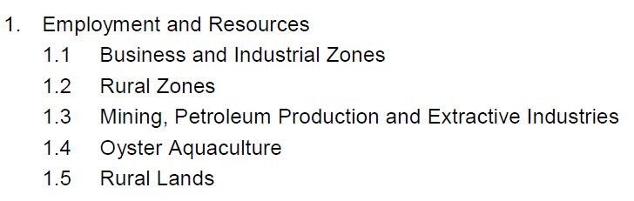 | JUSTIFIABLY INCONSISTENT – Although the Planning Proposal seeks to rezone industrial land to residential, it is considered that the subject site is more suited to residential development than light industrial use due to neighbouring land uses and proximity to public transport and the local business centre. The previous business has relocated to a more suitable site.
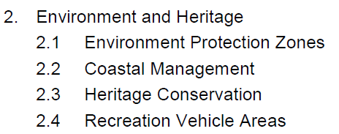 | CONSISTENT – The Planning Proposal will not impact any of the  matters identified in this Direction.
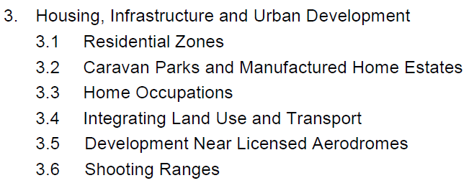 | CONSISTENT – The Planning Proposal will assist in the provision of affordable housing supply and choice close to public transport and with other infrastructure available.
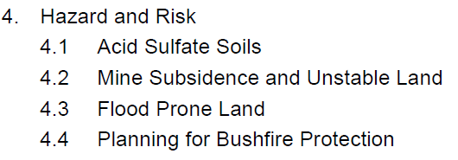 | CONSISTENT – The Planning Proposal will not impact any of the matters identified in this Direction.
5. Regional Planning  5.1 Sydney Drinking Water Catchments  5.10 Implementation of Regional Plans | CONSISTENT – The relevance of these matters to the Planning Proposal is addressed elsewhere in this Proposal.

ENVIRONMENTAL, SOCIAL & ECONOMIC IMPACTS

The Planning Proposal will provide a positive social impact by providing afforable housing supply and choice.

STATE & COMMONWEALTH INTERESTS

No public infrastructure is required for any proposed amendment.

REFERRALS & CONSULTATION

Referral to Water NSW will occur as required under the Gateway Determination. Any other referrals required will also be undertaken prior to public consultation of the Planning Proposal.

Community consultation will occur as directed in the Gateway Determination and in accordance with the Department’s Guide to preparing LEPs. It is noted that Council normally provides at least 28 days of public exhibition which includes weekly advertising in the Southern Highland News for the duration of the exhibition period and notification by letter/email to property owners deemed affected by the Proposal where appropriate.

Details of the Planning Proposal and all relevant documentation are provided on Council’s website. Relevant material is also provided at the Customer Service Counter at the Civic Centre and at all libraries including Council’s Rural Outreach & Delivery Service (ROADS) Mobile Library.

PROPOSED TIMELINE

It is anticipated that the Planning Proposal will progress in accordance with the following key timeline milestones:

MILESTONE | INDICATIVE DATE
Gateway Determination | May 2018
Agency Consultation | June 2018
Public Exhibition | July 2018
Report to Council on exhibition of Planning Proposal. | August 2018
S.3.36 Documents to DP&E & PCO. | August 2018
Approximate completion date | September 2018

DELEGATIONS

Council is applying to use its delegations to complete this Proposal. The Department’s form Evaluation Criteria for Delegation of Plan Making Functions has been attached for consideration.

